**Educational Organisation Using Service Now**

**TEAM ID :** NM2025TMID13322

**TEAM LEADER:** BALAJI.S

**TEAM MEMBER 1 :** DIVIYAN .S

**TEAM MEMBER 2 :** DHAYANITHI.S

**TEAM MEMBER 3 :**DHATCHANAMOORTHY.R

**Activity 1 : Service Now developer sign-in up**

* + - **Sign up for a developer account on the ServiceNow Developer site** [**https://developer.servicenow.com**](https://developer.servicenow.com)**.**
* Once logged in, navigate to the “Personal Developer Instance” section.
* Click on “Request Instance” to create a new ServiceNow instance.
* Fill out the required information and submit the request.
* You’ll receive an email with the instance details once it’s ready.
* Log in to your ServiceNow instance using the provided credentials.
* Now you will navigate to the ServiceNow.

**Activity 2 : Create a update set**

* Click on All >> Local update sets
* Click on new
* Enter the Details Name: Educational Organisation >> Click on Submit and make Current.
* 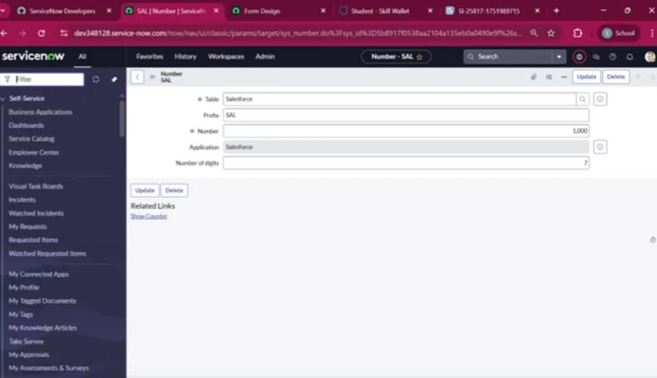Click on submit

**Activity 3 : create a table**

* Click on new
* Enter the Label(Anything you want): Salesforce >> Click on Name it will Automatically generate Api name.
* Create columns as given below,Double Click on Column label and Enter the Column labels and click on the tick mark >> Give Type as given .
* For “Admin Number” Give Display as True and right click on the toggle bar on top >> save.
* 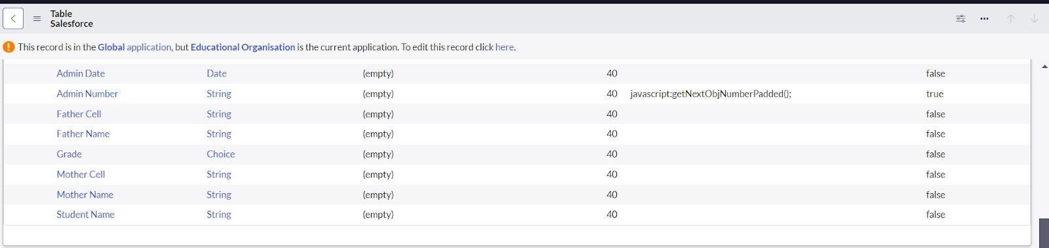For “Admin Namer” Give Display as True and right click on the toggle bar on top >> save.
* 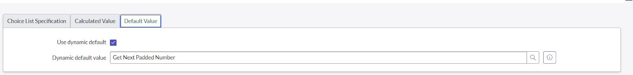Click on “Grade” Column >> Click on Choices and give Label,Value and Sequence as given below.
* Click submit

**Activity 4 : create admission table**

* Create an Admission Table with Columns given.
* Select Extends Table >> Salesforce and also Select Add module to menu >> Salesforce.
* Create Fields as shown
* 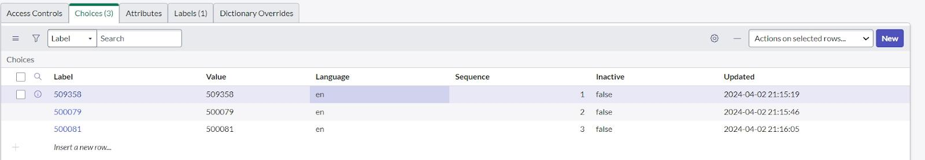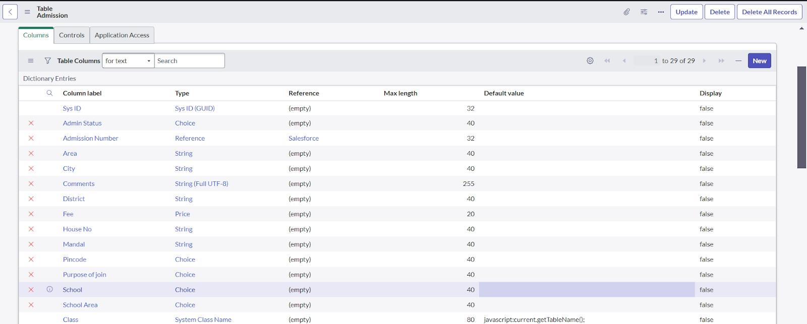click on submit.

**Activity 5 : Form layout**

**Configuring for form layouting**

* In the Student Progress Table Page , Click on Layout form .
* Select below Admission Number fields in Available side and send it to selected side as below >> save.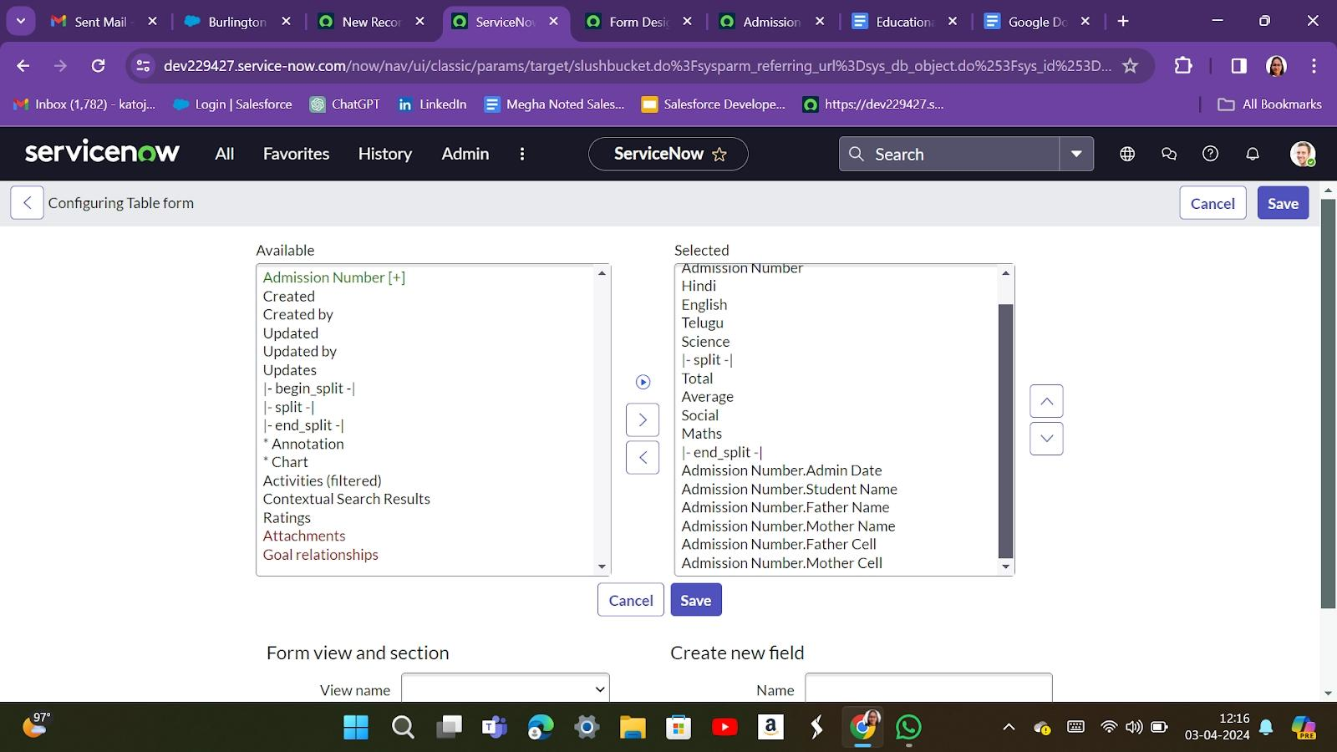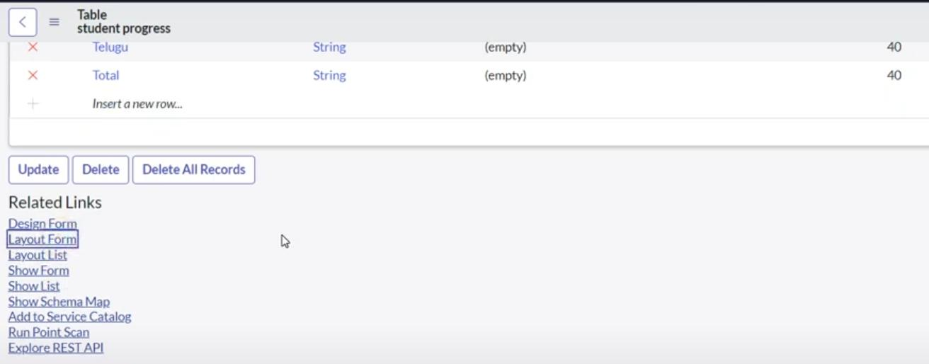
* Click on submit

**Activity 6 : Form design**

**Create a form design for salesforce, addmission, and student table**

* All >> System Definition >> Tables .
* In Label Search for Salesforce and open .
* Right Click on top Toggle >> Configure >> Form Design.
* In drop down select Salesforce(u_salesforce).
* Drag and drop the fields to the left side as below.
* Apply for all process (application & student table )
* Click save or update

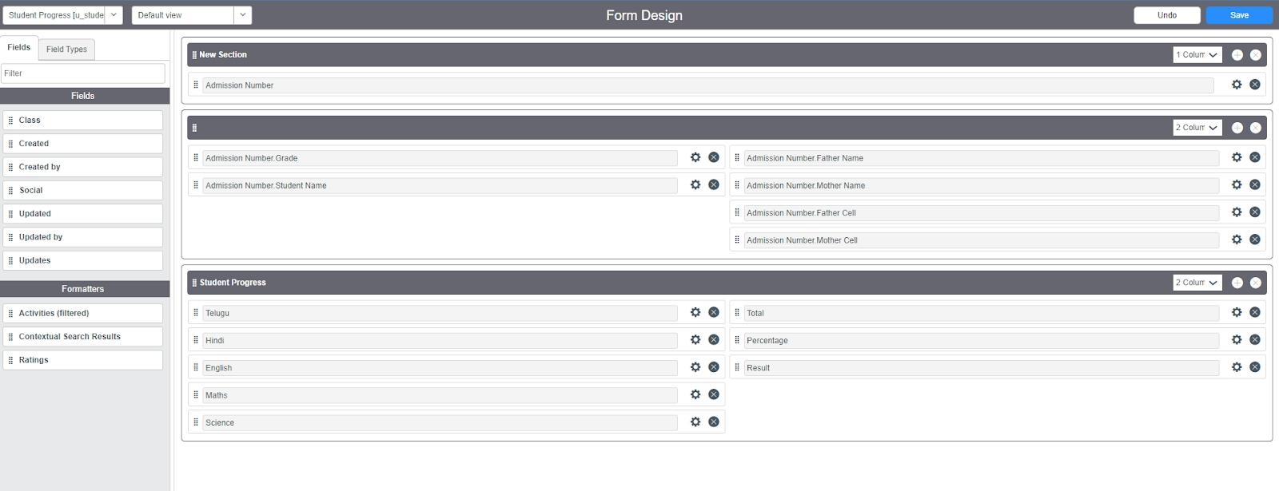

**Activity 7 : Number maintain**

**Create a number maintenance**

* All >> Number Maintenance >> New
* Fill the details >> Submit

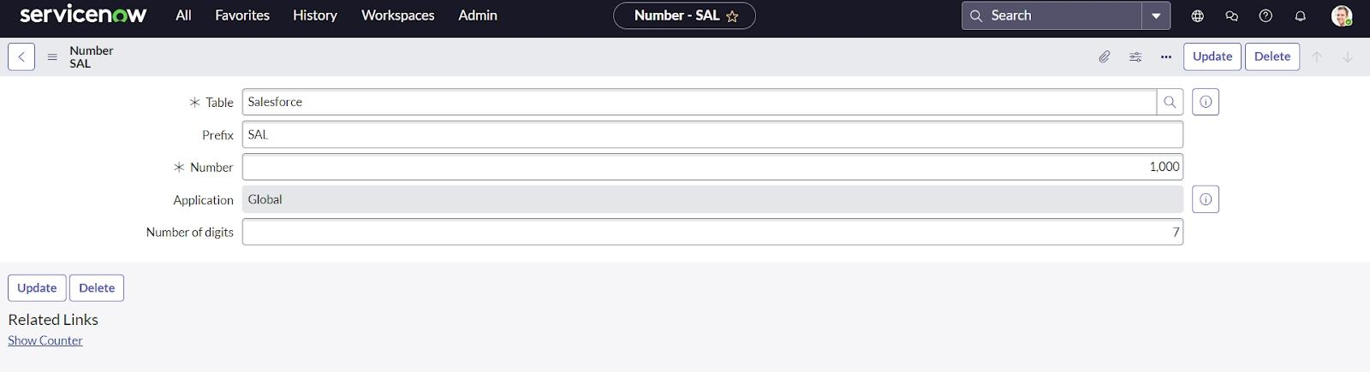

**Activity 8 : Process flow**

**Creating process a flow for Addmission table**

* All >> Process Flow>> New.
* Fill the Details as given Below
* Right Click on toggle and click on the save .
* Replace the Name and Label as below and click on Insert on stay
* Replace the Name and Label in order and click on Insert on stay
* Joined >> Rejected >> Rejoined >> Closed >> Cancelled.
* Order should be New >> InProgress >> Joined >> Rejected >> Rejoined >> Closed >> Cancelled.
* 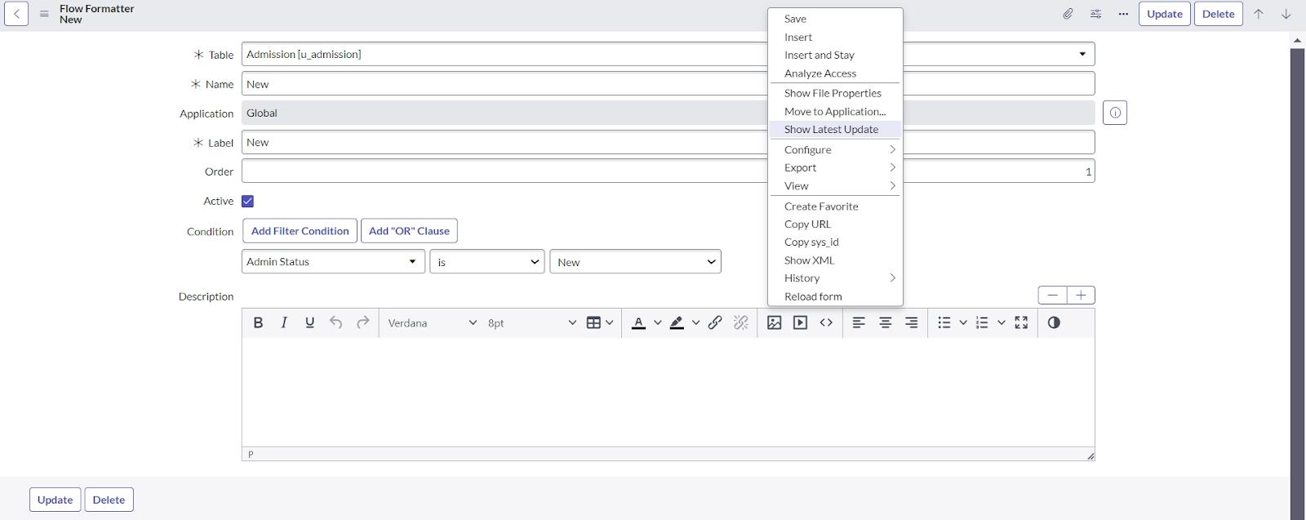
* Click save

**Activity 9 : Client script**

**Create a client script**

* All >> Client Scripts >> New.
* Fill the Details as given
* Replace the Name and Label in order and click on Insert on stay.
* Joined >> Rejected >> Rejoined >> Closed >> Cancelled.
* Order should be New >> InProgress >> Joined >> Rejected >> Rejoined >> Closed >> Cancelled
* 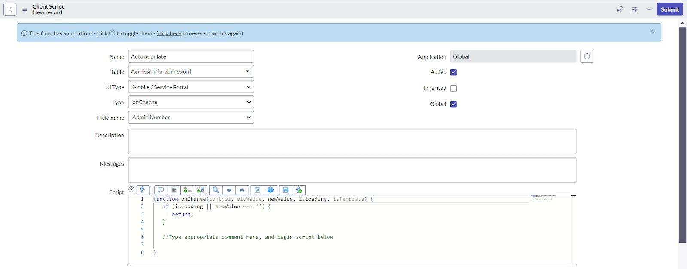and add the flow script code given bellow
* Click submit

**Activity 10: Result**

* Result for all the client script flow
* For example
* 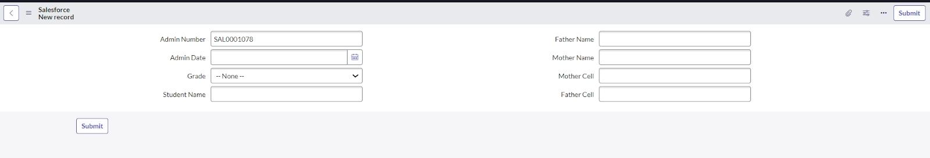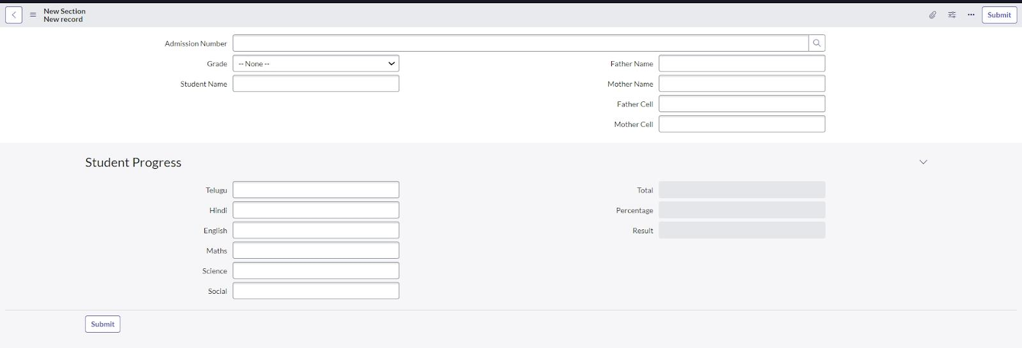**click submitted**

**Activity 11 : Conclusion**

The Educational Management System is a comprehensive platform designed to streamline administrative tasks within educational institutions. It facilitates efficient management of student and teacher data, simplifies the admission process, and provides tools for monitoring student progress.